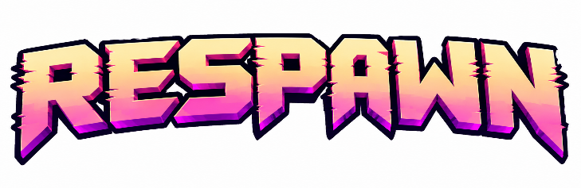
GAME DOCUMENTATION
Complete the fields below and upload the finished document as a PDF.

Team Details

- Team Number:
________________________________________________________________________________
- Team Name:
________________________________________________________________________________
- Team Lead Name:
________________________________________________________________________________

Game Description

- Game Title and Genre (e.g., Running, Platformer, Puzzle, Driving):
Quad Shot (Respawn — 2D Cartesian Roguelike) | Genre: 2D Open-World Roguelike / Twin-Stick Vector Action / Arcade Arena Shooter
- Brief Description — explain the concept and objective of your game:
Quad Shot is a high-speed, physics-driven 2D open-world roguelike set on an infinite Cartesian coordinate plane where mathematical kinematics are made physical. Players control an agile protagonist known as "The Origin Point (0,0)"—featuring fluid martial-arts vector combat and interchangeable cyberpunk avatars. Players navigate four dynamically shifting quadrants (Domain of Order, Parabolic Wastes, Fractal Depths, Zero-G Void), survive escalating wave lockdowns, switch between Kinematic (zero-drift) and Inertial (momentum-drift) physics engines on the fly, toggle between Ranged (aim-and-fire) and Melee (blade slash & projectile-deflect) combat modes, conquer geometric Mini-Bosses every 5th wave, and defeat Wave 100 Boss "The Corruption Vector".
- Connection to the Mystery Theme — how does your game interpret the given theme?
Quad Shot interprets the Mystery theme through an unstable mathematical simulation. The protagonist awakens at (0,0) with no memory other than spatial coordinates, exploring an anomalous Cartesian matrix corrupted by The Corruption Vector. Upon death, the Quadrant Scrambler alters the spatial positions and physics laws of the four biomes, forcing players to deduce shifting environmental equations on every run. By unravelling hidden kinematics (switching between Kinematic and Inertial frames, time-slowing Suspension State, and trajectory-revealing Intersection Pauses), players transmute collected Vertices into Prime Matrices at the Origin Terminal to decode permanent Algorithmic Tree upgrades and solve the matrix mystery.

Technical Details

- Tech Stack — game engine, programming language, and tools used:
Game Engine: Custom-built HTML5 2D Canvas Engine with spring-damper mesh grid deformation, particle physics, and vector kinematics.
Programming Languages: JavaScript (ES6+ modular architecture: math, grid, stickman, weapons, enemies, bosses, sprite_manager, audio, economy_meta, game), Go (Golang 1.22+ cross-platform standalone runner and self-healing asset recovery engine), HTML5 & Vanilla CSS (cyberpunk Tron HUD, CRT scanlines, glassmorphism), Python 3 (asset pipeline & bundle compiler).
Audio Engine: Real-time Web Audio API procedural synthesizer (zero audio file dependencies).
Distribution: Go cross-compiled native desktop binaries for Windows (quad_shot.exe), Linux (bin/quad_shot-linux), and macOS (bin/quad_shot-macos, bin/quad_shot-macos-arm64).
- AI Tools Used — mention the tools and how they were used
Google DeepMind Antigravity / Gemini Coding Assistant:
• Mathematical Kinematics & Physics: Formulated and verified 2D Cartesian vector math, sine wave bullet oscillations, parabolic ballistic arcs, line-segment intersections, and spring-damper grid warping.
• Modular System Architecture: Structured clean ES6 modules separating game rendering, physics frames, hostile AI state machines, procedural audio synthesis, and meta-progression.
• Desktop Executables & Self-Healing Engine: Engineered the Go desktop application runner featuring embedded asset recovery, ephemeral port allocation, and chromeless native window launching.
• Asset Pipeline & Optimization: Integrated 20 cyberpunk character sheets, 40 pixel weapon icons, and 10 cartoon slash animation sets, optimizing bundle sizes to ~9.5 MB standalone binaries.
- Repository / Libraries / External Resources — provide links and mention any libraries or assets used:
Repository: https://github.com/arvind-harish-746/Respawn-roguelike
Libraries: Native Web APIs (HTML5 Canvas 2D, Web Audio API procedural synthesis, RequestAnimationFrame, localStorage) with zero third-party JS dependencies; Go standard library (embed, net/http, os/exec).
Assets: Neon Cyber Pixel RPG Sprite Pack (sprites/release/cyber), Pixel Weapon Icons Pack (sprites/weapon_sprites/1 Icons/), Cartoon Slash Sprite Effects (sprites/slash-sprite-cartoon-effects/PNG/), Google Fonts (Inter, Orbitron).

Game Screenshots
Include 2–4 screenshots showing the actual gameplay, main menu, key mechanics, or important features of your game.

